**COMP 3059 – Capstone Project I**

**Software Requirements Analysis and Design**

# 1.0 Introduction

“Rentitus” is a Canadian online advertising platform especially for renting wide range of Items.

## Purpose

This project is to design and build an online application to meet the “Rentitus” application needs and verify application’s standard useability.

## Scope

RentWorks online website should be a handy and safe application for someone who wants to rent their stuff and who wants to rent the item they need.

# System Overview

Rentitues first available online as a website. Our online application system focusses on two main point, first and most is safety and easy to rent. Transaction should be safe, secure user’s personal privacy, and detect unsafe users on time.

## Project Perspective

Rentitues web application’s core perspectives are:

* Safe
* Easy process.

## System Context

For expand utility and security of Rentitus application, system requires these functionalities includes 2 step user verifications, third party complementary insurance, safe transactions, delivery options, “detect & report” feature, and reliable database.

## General Constraints

Rentitus has limitations on these manners:

1. Geographically. At first, we release our application only in Toronto city, and expend our service based on the increase of our customers and profit.
2. Privacy. Due to privacy reason our application my lose potential customers.
3. Customer support. From the beginning, this application is built for someone who wants to reach low-cost items, for this reason this application except from basic infrastructure cannot provide high satisfied customer service. There will be no return, or exchange.

## Assumptions and Dependencies

* If user don’t provide their detailed information on 2nd step verification, the rental process will not be processed. For this reason, this application needs a user privacy protection legal agreement that pop up before they fill up their further information. This will help convince users feel secure to cooperate with verification.
* This application is about to rent an item and return it to the owner. On this process there has a hazard of vicious user, impairment, and scam. For prevent this potential risk, system needs 3rd party insurance and at the same time “detect & report” feature to drop vicious users.

## 3.0 Functional Requirements

This project is about renting and lending item that is categorized in home and office supplies, in most safest and handy way to process users requirements and complaints.

### 3.1 <Functional Requirement or Feature #1>

* Introduction

Rentitus is online website should be a handy system for someone who wants to rent their stuff and who wants to rent the item they need.

* Inputs

For an input, our application requires users email and password for sign in. without sign in user cannot see any item information on the application.

* Processing

In rental processing, when user ready to post their items for lend or to rent an item that is available on the website, user need to provide their information for validation, then user can be able to have a conversation with the other verified user.

* Outputs

After they come to an agreement, our rent application will collect renter’s and lender’s transactional data and take 7% of lenders profit. Based on the renter’s review, we promote lenders credibility.

## 3.2 Use Cases

### 3.2.1 Use Case #1 ..

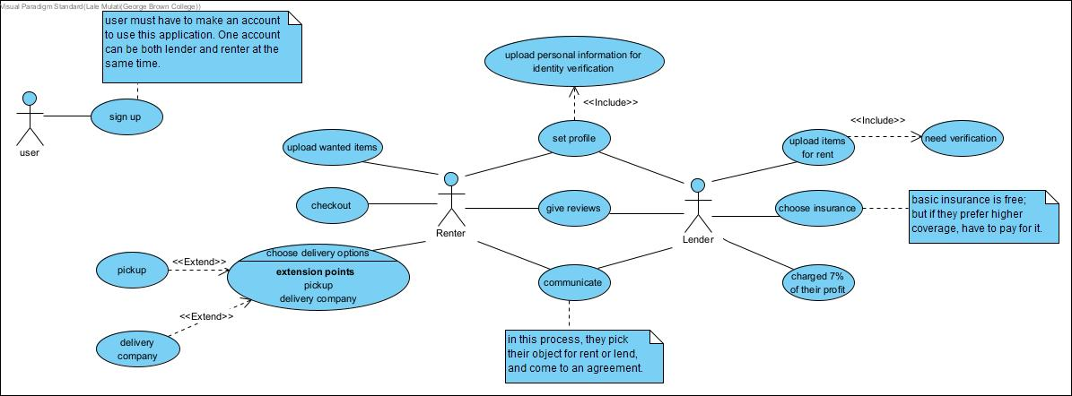

**3.3 Data Modelling and Analysis**

* Normalized Data Model Diagram

* Activity Diagrams

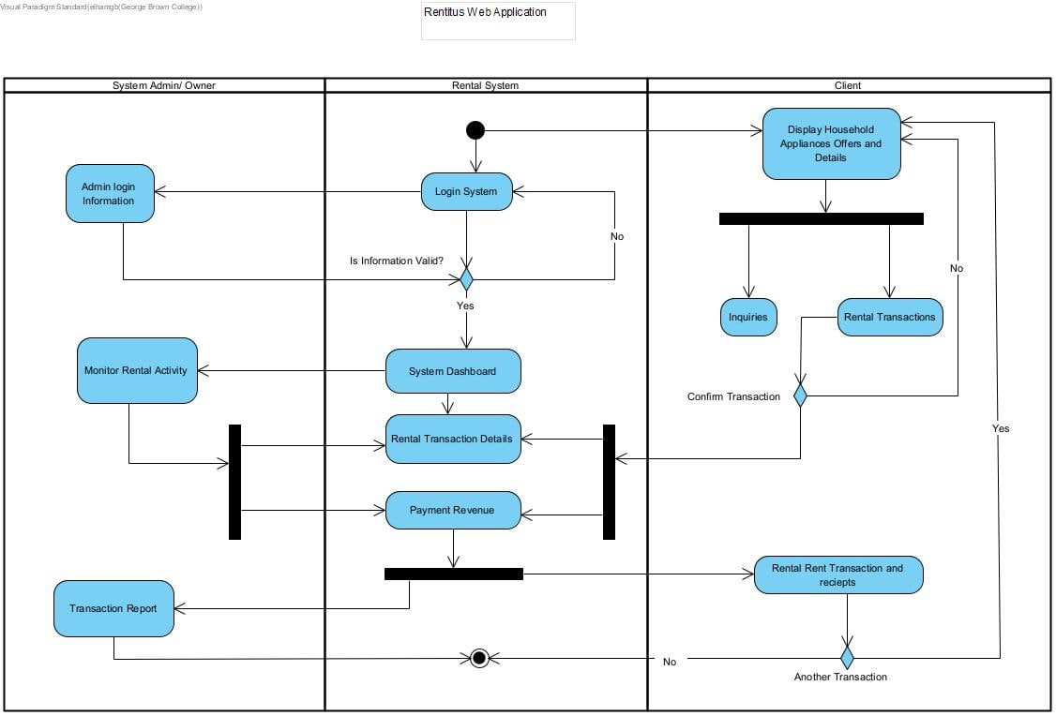

* Sequence Diagrams

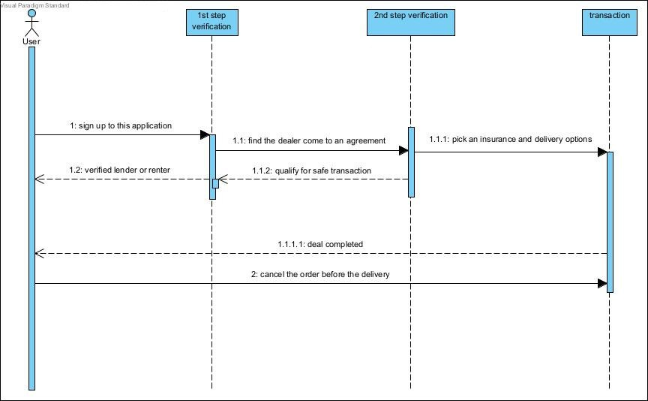

* UML Class Diagram

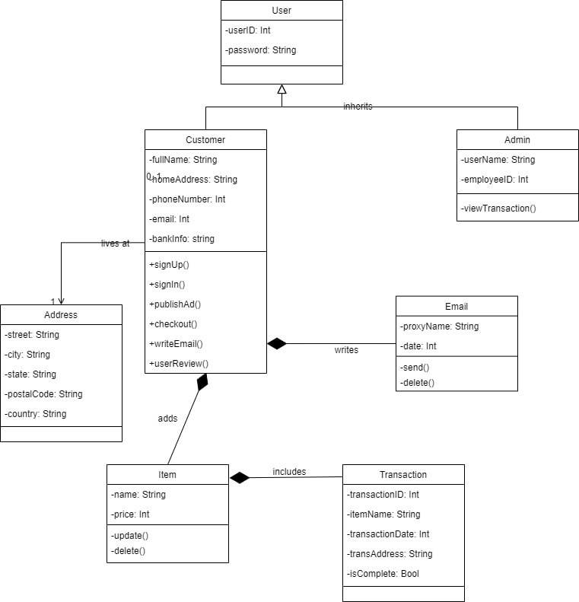

**3.4 Process Modelling**

* Data Flow Diagram

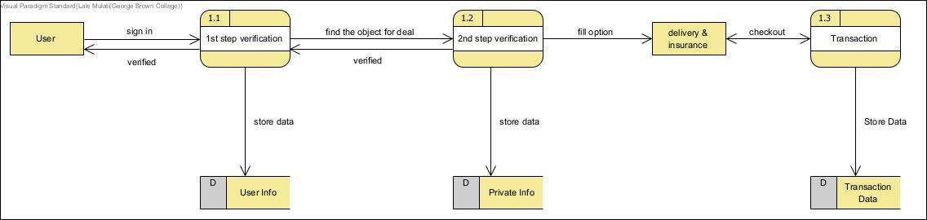

## 4.0 Non-Functional Requirements

Category: Performance

Description: Rentitus application should show the item address on the map, for accessibility.

Category: Security

Description: We chose safe transaction protocols to protect renters’ safety.

Category: Data Integrity

Description: For safe rental process, the data provided by the renters and lenders should be verified by 3 steps, that’s including sign up verification, verification code before transaction, and repot.

Category: Backup

Description: For data safety, data needs to be stored on database and backup on cloud storage.

Category: Elasticity

Description: User after sign up can be both renter and lender at the same time.

## 5.0 Logical Database Requirements

We need database with three indexes:

* Relational
* Need GIS support
* Open Source

Our data model is relational, so with a relational database we can make better reports.

We chose PostgreSQL because we should use GIS methods and PostgreSQL is completely mature for it. On the other hand, PostgreSQL is an open-Source Database that for start is not costly.

Heroku allows developers to choose from several databases and data stores according to the precise needs of individual applications. The developers can take advantage of the PostgreSQL database as a service to make the application access data quickly and keep the data secure. On the other hand, we can start free with Heroku and for student project is low cost.

AWS, Azure and google cloud are not free at the start.

## 6.0 Other Requirements

Additional requirements, if any.

**7.0 Approval**

The signatures below indicate their approval of the contents of this document.

|  |  |  |  |
| --- | --- | --- | --- |
| Project Role | Name | Signature | Date |
| Frontend Developer | Abdelaziz Omar | Abdelaziz | Nov.2,2022 |
| Backend Developer | Artem Elagin | Artem | Nov.2,2022 |
| Data Manager | Elham Veisouei | Elham | Nov.2,2022 |
| Testing Engineer | Lale Mulati | Lale | Nov.2,2022 |